FOR IMMEDIATE RELEASE

Albury Brothers & Jr. Angler
Score Big at Silver Sailfish Derby
January 14, 2005 – Twelve year old junior angler Andrew Simko was awarded the Louis S. Boski Memorial Trophy for the Most Outstanding Catch at the 68th annual West Palm Beach Fishing Club’s Silver Sailfish Derby. The Silver Sailfish Derby is the longest running Billfish Tournament in the US.
Andrew, teamed with his Dad, J. Michael Simko, David D’Agresta and a Albury Brothers 23 footer caught, released and tagged his first and second sailfish during tough conditions. These fish also proved critical to helping Team Albury Brothers capture second place "Tag Team" for most tagged sailfish. Two limited edition autographed prints were awarded as prizes.
The Albury Brothers 23 was the smallest boat in the tournament, yet the Simko’s were able to fish further north than most competitors. The Simko’s credited the boat’s ride with enabling them to run hard and fast to the prime fishing grounds. "The Albury 23 rides better in most conditions than my 26 footer. Top speed is not as important as top usable speed, which the Albury has in droves. She also tracks beautifully and barely rolls while drifting."
Albury Brothers Boats (www.alburybrothers.com) are built in Man O’ War, Abaco, Bahamas and Riviera Beach, Florida. Albury Brothers Boats have been built for over 50 years by three generations of the Albury family.
For additional information, contact Jeff Lichterman of Albury Brothers Boats
at 561-863-7006 (info@alburybrothers.com) or visit our website atwww.alburybrothers.com.

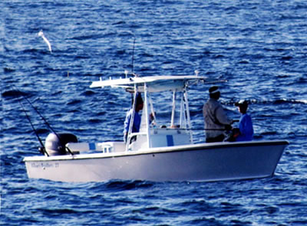 | 